Strategic fisheries closure balances harvest opportunity and stock diversity in a large Alaska river basin.

Ben Makhlouf, Daniel E. Schindler, Timothy J. Cline, Diego Fernandez, Janessa Esquible, Avery Hoffman

Abstract:

Effective conservation of exploited species requires balancing harvest opportunities with the protection of biodiversity. In Pacific salmon populations, biodiversity among populations represent a critical dimension of biodiversity that generates basin-wide resilience. However, spatiotemporal dynamics of adult migrating Chinook salmon remain poorly understood, producing uncertainty about the stock-specific impacts of management actions and their consequences for basin-wide biodiversity. Declining abundance of Chinook salmon in Western Alaska watersheds has led to restrictions in subsistence harvest and significant challenges for upstream communities. To balance stock protection with harvest opportunities, a front-end closure informed by traditional knowledge has been implemented to limit fishing opportunities during the beginning of the run to reduce exploitation of fish migrating to the top of the watershed. To quantify the potential stock-specific impacts of this strategy, we
reconstructed the spatiotemporal dynamics of return migration timing for Chinook salmon to the Kuskokwim River of western Alaska across six years using otolith isotope signatures. From these data we examined the impacts of a front-end fishery closure on the tradeoff between protection of sub-stock biodiversity and harvest opportunity.
We demonstrate a consistent relationship between seasonal run timing and watershed origin of returning fish; earlier migrating fish contributed disproportionately to the uppermost regions of the watershed. This trend was consistent when examining relative watershed contributions within discrete temporal windows during the return migration as well as in cumulative distribution analyses that controlled for total return abundance. While this pattern was robust, we did observe interannual variability in the magnitude of watershed contributions and overall run timing, highlighting the interactive relationship between the closure and dynamic ecological processes which may impact its efficacy.
The front-end closure strategy consistently provided higher protection to upper watershed stocks across several simulated alternative front-end closure end date scenarios. However, the tradeoff between the stock-specific conservation benefit afforded and foregone potential harvest opportunities changed significantly based on simulated end dates.

Introduction:
A key challenge in the management of harvested species is balancing the dual goals of providing adequate harvest opportunities while preserving biodiversity. In this context, biodiversity can be defined both by the number of species within an ecosystem as well as intrapopulation diversity among metapopulations of a single species (Bolnick et al., 2011; Luck et al., 2003; Schindler et al., 2010). In either case, biodiversity stabilizes ecosystem level processes, bolsters resilience to environmental change, and increases the reliability of ecosystem services ( Schindler et al., 2015; Tilman et al., 2005). Designing strategies that explicitly protect biodiversity, however, require a thorough understanding of the potential consequences of different strategies on both harvest and ecological processes as well as the tradeoffs between them. In many cases, such as in large and remote ecosystems, understanding these patterns at sufficient spatial or temporal scales remains a challenge, resulting in conservation and resource management strategies with uncertain outcomes.
Pacific salmon (Oncorhynchus spp.) returning to their natal watersheds often exhibit significant diversity in run timing and spatial distribution across large and complex river systems (Griffiths et al., 2014; Nesbitt & Moore, 2016; Schindler et al., 2010). Populations of adult salmon migrating upstream within large river basins are often comprised of multiple distinct sub-stocks (or populations) which vary in their relative abundance and life-history, but which co-migrate within overlapping temporal windows. Downstream fisheries that harvest migrating individuals therefore risk overexploitation of vulnerable populations which co-mingle with more robust ones (Connors et al., 2020; Moore et al., 2021). Populations returning to the furthest upstream portions of the watershed face particular risk of overharvest given their extended migration and sequential nature of large river salmon fisheries (e.g. Hamazaki, 2008). However, the timing, yield, and duration of downstream fisheries is the result of the aggregate dynamics of these upstream components (Nesbitt & Moore, 2016). Further, maintaining life history diversity across the full stock complex contributes to ecosystem resilience by distributing population level risk across space and time (Schindler et al., 2010). Designing strategies which explicitly consider and protect this biodiversity, including vulnerable upstream populations, therefore contributes to stabilizing downstream fishery resources.
Western Alaska watersheds contain some of the last remaining pristine salmon habitat and have historically supported large returns of Pacific salmon. The region’s three major river basins, the Yukon, Kuskokwim, and Nushagak, collectively produce approximately 80% of the world’s wild Chinook salmon, making western Alaska one of the most important remaining strongholds for the species globally (Oncorhynchus tshawytscha). However, several species of Pacific salmon, including Chinook salmon, have declined precipitously in recent years throughout Western Alaska watersheds (KRITFC, 2024; Lamborn et al., 2025a; Ohlberger et al., 2018), triggering a conservation crisis and leading to heavy restrictions on subsistence harvest (Brown & Godduhn, 2015; Lamborn et al., 2025b; Ohlberger et al., 2018). In the Kuskokwim River basin, a large (127,000 km²) free flowing watershed in western Alaska, Chinook salmon populations support subsistence fishing opportunities for dozens of rural communities, comprised by a majority of Alaska Natives (ADFG, 2025). Subsistence fisheries are the primary form of harvest in the watershed, and nearly every household participates in the fishery in some way. As a result, fishery restrictions have led to significant hardship in the basin, including food insecurity and cultural loss (Brown & Godduhn, 2015). Resource managers are therefore tasked with designing management strategies that allow for harvest opportunities while simultaneously rebuilding basin-wide abundance and maintaining population biodiversity across the watershed.

A current management approach implemented in the Kuskokwim River basin has been a front-end closure which prohibits fishing during a fixed temporal window from June 1st to June 11th. This strategy is designed to protect early migrating fish which are assumed to be returning to spawn in the furthest upstream regions of the Kuskokwim River. This assumption is bolstered by patterns observed in other systems (S. C. Clark et al., 2015), supported by telemetry data in the Kuskokwim (J. N. Clark & Smith, 2019; Head et al., 2017; Smith & Liller, 2017a, 2017b), and further motivated by traditional and local knowledge held by Tribal citizens and stakeholders. By protecting upriver stocks, managers aim to support basin-wide escapement goals, provide more equitable harvest opportunities to upstream communities, and protect upper river stocks which are at heightened risk of overharvest but contribute disproportionately to stabilizing downstream fishery dynamics. However, the spatial ecology of Chinook salmon in the Kuskokwim River basin remains poorly understood at the watershed scale, and whether the interaction between population-specific migration patterns and the front-end closure has the potential to protect upstream stocks as intended is not currently well known.
Here, we use otolith chemistry from fish caught during a test fishery throughout the seasonal migration period over six years in the Kuskokwim River to reconstruct spatiotemporal patterns of Chinook salmon returns. The limited genetic structure of Chinook salmon in this region precludes using genetic approaches to quantify migration timing of different populations throughout the watershed. Otolith-based methods for estimating provenance therefore offer a novel approach to: (1) identify the spatiotemporal structure of returning populations in the Kuskokwim River basin, and (2) evaluate potential impacts of front-end closures on conserving population diversity within salmon stock complexes returning to large, remote, watersheds.

Materials and Methods:
Otolith samples
Chinook salmon otoliths were collected from 2017 to 2022 in the Alaska Department of Fish & Game Bethel Test Fishery (BTF) near Bethel, Alaska in collaboration with the Orutsaramiut Native Council fisheries program. The BTF was designed to enable in-season assessment of run timing and strength, based on catch-per-unit-effort (CPUE), to inform management decisions for fisheries throughout the river. Fish caught in this fishery are a representative sample of returning stocks throughout the basin above the test fishery location (Lipka & Elison, 2015). Although this sample set does not capture fish which spawn below Bethel, nearly all Chinook salmon returning to the Kuskokwim River spawn above this location. Contributing partners collected approximately 500 otoliths annually from 2017-2022, ensuring sampling efforts over the full course of the run. From these, approximately 250 otoliths were selected for chemical analysis in proportion to the relative CPUE throughout the season.
Otoliths were sectioned with low speed diamond blade isomet saw along the transverse plane, mounted on microscope slides, and polished to expose internal growth structures (Donohoe & Zimmerman, 2010; Zimmerman & Reeves, 2002). Prepared samples were analyzed at the University of Utah Strontium Isotope Laboratory using laser ablation inductively coupled plasma mass spectrometry (LA-ICP-MS). Laser ablation was conducted along a transect from the otolith core to just beyond the onset of marine growth (identified by the dark annuli check indicative of marine entry) using a 53 μm diameter beam and scanning at 2μm/second. The resulting data represent a continuously integrated measurement of Sr⁸⁷/Sr⁸⁶ from early development until marine entry (Brennan et al., 2015; Campana, 1999; Capo et al., 1998). From these data, the Sr⁸⁷/Sr⁸⁶ value associated with the natal freshwater rearing period was extracted by examining patterns of change in Sr⁸⁷/Sr⁸⁶ and Sr⁸⁸ between the core and freshwater region, morphological features of the otolith visible along the ablation path, and known distances from the core to onset of the freshwater signal (Brennan et al., 2019; Chittaro et al., 2023).

Natal Origin Estimation
A strontium isoscape of the Kuskokwim river basin (Fig. 1) was constructed by French et al., (2020) in which spatial variation in Sr⁸⁷/Sr⁸⁶ ratios across the river basin was modeled using spatial stream network modeling (SSNM) derived from water samples collected throughout the river basin (French et al., 2020, N = 120). The resulting isoscape includes estimates of Sr⁸⁷/Sr⁸⁶ ratios and associated uncertainty for roughly every ~1km of river length across the basin (Fig. 1) (Brennan et al., 2016; Ver Hoef & Peterson, 2010). To prevent over-assignment to tributaries with exceptionally low prediction error, uncertainty values were constrained to 0.0006 and above. This threshold was selected by visually examining the histogram for a cutoff which adjusted the values for a small number of exceedingly low uncertainty tributaries (those near extensive sampling) while maintaining the general error distribution from the original SSN model.
Posterior probability values were calculated for assigning all fish to potential tributary segments across the river basin using a geographically continuous Bayesian framework (Brennan et al., 2019). This approach considers the relationship between extracted natal origin otolith Sr⁸⁷/Sr⁸⁶ values as well as several variance generating processes including analytical, within-population, and isoscape prediction errors. We assumed all errors were normally distributed, and combined them through the equation:
$$σ_{combined= \sqrt{σ_{Analytical}^{2}+ σ_{Within-population}^{2}+ σ_{isoscape}^{2}}}$$
Posterior probability values for each tributary (j) were then calculated using Bayes theorem (Brennan & Schindler, 2017; Wunder, 2010) ;
$$P\left(J=j \right| O=o, R=rj) ∝ \left({1-\frac{1}{2πσ_{combined}}}^{{(-(o-r_{j})}^{2}/2σ_{combined})} \right)* Phabitat\left(j\right)* PStreamOrder\left(j\right)* PPresence(j)$$
The probability of an individual assigning to tributary j is defined as the product of the probability of the isotope ratio in the otolith of an individual (o) given the isotope ratio in tributary j (r_j). The probability of the isotope ratio (rj) was assumed to be normally distributed with a mean represented by the otolith isotope ratio (o) and an error of $σ_{combined}$.
Several priors were included to limit assignments to areas within the river basin suitable for spawning Chinook salmon. First, a stream order prior (PStreamOrder) was applied to limit assignments to tributaries with a stream order of three or greater, reflecting Chinook salmon’s known preference for spawning in larger streams (Quinn, 2018). Reaches with a stream order of three or greater were included in assignments (assigned a prior value of one), while smaller tributaries were excluded (assigned a value of zero). Second, a habitat suitability prior (PHabitat) was used to exclude exceedingly slow or flat reaches determined to be unsuitable for spawning Chinook salmon (Makhlouf et al., 2025). Finally, data was included on observed locations of Chinook spawners derived from USGS Arctic-Yukon-Kuskokwim (AYK) Chinook Salmon Intrinsic potential mapping, which synthesized several sources of data on observed Chinook salmon spawners into spatially referenced tributary data on the presence or absence of observations (Falke & Paul, 2025). To avoid biasing regions without observations but with low sampling effort this prior was applied only to the two highest stream orders in the dataset (Stream order greater than five). From these tributaries, reaches identified as lacking observed Chinook spawning were assigned as a value of zero.
To estimate the spatial distribution of returns across a subset of the population, posterior probability values for all individuals in that subset were summed at each location. Before summing, only highly likely locations (the top 30% of posterior values) were retained whereas all other values were assigned a value of zero (Brennan & Schindler, 2017; Vander Zanden et al., 2015). We produced these estimates for four predefined temporal quartiles of the salmon migration season based on capture date: Q1 (run start through June 11), Q2 (June 12-21), Q3 (June 22-July 1), and Q4 (July 2 onward). These dates were chosen to roughly split the full run into quartiles while allowing for direct comparison among years. The June 11 date was chosen specifically to match the end of the ‘front end closure’ of the subsistence fishery. Estimates were also produced for the full run in each year.
Several major tributaries were identified in the Kuskokwim River Basin. From the furthest downstream connection of each of these tributaries to the mainstem Kuskokwim River, all upstream segments were identified and assigned to a common identifier based on the name of the major tributary. Areas of the basin which were not assigned a unit identifier (e.g. portions of the mainstem Kuskokwim) were grouped into regions of comparable size and spatial relevance to ensure complete basin coverage above the location of the test fishery (Fig. 2a). To identify regions of the watershed that can be distinguished based on their isotopic composition, we performed k-means clustering of initial tributary groupings using the full range of ⁸⁷Sr/⁸⁶Sr values found in each. We then evaluated the clustering results for a range of cluster numbers (n = 2-6) using the silhouette score, which measures cluster quality by comparing within-cluster versus between-cluster distances. From this metric we selected n = 6, which maintained a high silhouette score while providing finer isotopic resolution across groups. The resulting regional groupings displayed a general pattern from upstream to downstream regions (Fig. 2b). However, K-means clustering placed the South Fork Kuskokwim in a lower watershed group because of a very small number of enriched tributaries at the headwaters of this group. Based on an evaluation of the overall isotopic composition compared to other nearby tributary groups we manually added the South Fork Kuskokwim to its nearest watershed group, group five.
Spatiotemporal Stock Contribution Analysis
For each year and seasonal quartile, tributary-level return estimates were aggregated into the six regional groups and normalized to sum to one across the basin, representing each group’s proportional contribution to that quartile. Summary statistics were then calculated across all years for each group (Fig. 3). Cumulative distribution functions were constructed to examine trends in relative run timing among regional groups independent of abundance and quartile cut-off dates. For each year, the full run was split into three-day intervals and the cumulative number of returners for each group was compared to its full season contribution. To directly compare relative run timing to the temporal distribution of the full run, we used daily CPUE data collected from the BTF to calculate the cumulative proportion of the full run’s CPUE remaining for each day. This value represents the maximum potential harvest available if harvest rates are proportional to CPUE. However, this value does not account for the preferred harvest timing without the closure implemented, which may not follow this pattern. Resulting data (Fig. 4) illustrate the proportion (from zero to one) of each group’s total cumulative contribution to the overall run at each three-day interval as well as the proportion of the total potential harvest remaining for each day.
To assess the impact of the existing front-end closure, we quantified the share of each group’s total annual return that fell within the closure period (the first seasonal quartile, Q1 in our dataset). This comparison illustrates the maximum degree of protection provided to each stock group by estimating the portion of its annual run excluded from harvest. We then assessed the same metric but with a set of alternative closure durations by calculating proportional protection at three alternate end dates for the closure: June 8rd (three days before current closure end date), June 14th (three days after current closure end date), and June 17th (six days after current closure end date) (fig. 5). For each scenario, we calculated the proportion of the total CPUE that occurred within the adjusted closure window and compared this value to the potential protection afforded to each group across all years (fig. 6). Together, these results illustrate the tradeoff between increased protection under later closure end dates and the corresponding loss of potential harvest opportunity for stakeholders in the basin.
Results
Variation in stock return timing within season
Across all years of our dataset (2017-2022), returns to the six regional groups exhibited a general transition from the furthest upstream to the furthest downstream as the season progressed (Fig 3.). Notably, group one, which contains the North Fork and East Fork Kuskokwim River, consistently contributed little to all years and quartiles (max: 2.9%). Early season returns (Q1: start of run through June 11, Fig. 3a.) were represented primarily by high contributions from group two (median: 42.2%), with relatively low median contribution (20% or less) from all other groups. The second quartile (June 12th – 21st, Fig. 3b.) exhibited a slight decrease in contribution from group two (31.0%), with increasing contribution from groups four and five (25.8% and 19.8%, respectively). This pattern largely held in the 3rd quartile (June 22nd- July 1st, Fig. 3c.), with a further decrease in contribution from group two (21.6%) and an increased contribution from group four (30.1%). Finally, the fourth quartile (July 2nd onward, Fig. 3d.) exhibited a marked increase in median contribution from the furthest downstream group (group six, 17.9%), and contribution to this quartile was largely driven by groups four and five located in the bottom of the watershed (26.9% and 25.4%, respectively).
Cumulative distribution plots (Fig. 4) illustrated variation in seasonal migration timing among regional groups independent of the total returning individuals within each group. In each year, upper watershed individuals arrived earlier in the season whereas further downstream groups return later. There was some variability in run timing among middle/lower watershed groups, however, a clear pattern in run timing between the upper and lower portions of the watershed were evident despite differences in the average migration timing and temporal distribution of the run (i.e. extended vs protracted run timing) (Fig. 4, grey solid line). The proportion of total CPUE remaining at the front-end closure date (dashed grey line, Fig. 4) varied substantially among years. In some years, nearly the entire run had yet to arrive by the closure date (e.g., 2017), whereas in others, almost 25% of the total return occurred before the closure end date
Front-end closure protections
Early returning upper Kuskokwim populations were afforded higher proportional protection through the implementation of a front-end closure management strategy (Fig. 5). On average, group one, comprised of the furthest upstream populations, received 22.6% of its total contribution within the front-end closure window, followed by group two at 13.5%. In contrast, populations in further downstream areas received considerably less protection, with less than 10% protection afforded to groups three through six on average. These downstream groups also displayed a much narrower range of protection values across all years of our dataset: proportional protection ranged from 1.0 % -14% for groups four through six and 1.7% - 19% for group three. In contrast, upstream groups displayed a much larger range of protection across our dataset with group two ranging from 2.4% - 29.4% and group one ranging from 3% - 52% of the overall return protected by the front-end closure.
Varying the duration of the front-end closure did not change the overall pattern of higher protection afforded to upstream populations. However, an earlier closure date (June 8th) markedly decreased both the median and range of protection for upstream groups; median protection for groups one and two dropped to 5.4% and 6.7%, respectively. In at least one year of our dataset, ending the front-end closure three days early resulted in <1% protection for all groups, and no group received greater than 20% protection in any year. In contrast, extending the front-end closure later than the current date increased median protection across all groups. Groups one and two saw an increase of 17.4% and 9.1% in median protection, respectively, by extending the front-end closure three days and the same groups saw a 32.3% and 21.3% increase in protection by extending the front-end closure six days past the current closure date. Importantly, the minimum protection values in the three-day extension scenario were similar to the results of the current implemented closure. For a closure ending on June 14th, the lowest protection afforded to groups one and two were 7.8% and 4.4% respectively, which is only a 4.4% and 2.0% increase over the original closure date. By extending the closure by six days (June 17th), minimum protection values increased more prominently to 21.9% and 14.9% for groups one and two. While a longer front-end closure provides greater protection to stocks across the basin, it also increases the share of the total return that cannot be harvested. Under the current closure duration, an average of 12% of the total CPUE fell within the closure period. Shortening the closure reduces this loss to less than 5% but offers very little protection for upstream stocks (Fig. 5). Extending the closure, by contrast, substantially increases protection for several groups, however, an average of 17% and 24% of the total potential harvest fell within the front-end closure with a three or six-day extension to the current end date.
Discussion
The results presented here illustrate the most recent and comprehensive basin-wide quantification of the spatiotemporal patterns of Chinook salmon migrating into the Kuskokwim River. Our data corroborate previously observed relationships between run timing and watershed position of spawning habitat, wherein the earliest returning fish contribute to watersheds in the uppermost portions and the latest returning fish return to the furthest downstream portions of the watershed. This relationship was consistent throughout our multi-year dataset, emphasizing the consistency of this pattern across several generations despite variation in the overall migration timing and abundance.
A clear pattern of early-returning upriver populations supports the front-end closure’s objective of protecting these fish from downriver harvest and providing more equitable harvest opportunities in the upper watershed. Upper Kuskokwim groups contributed substantially to early-season migrants (i.e. group two); however, the furthest upstream populations (group one) consistently represented only a small portion of total basin-wide returns in our dataset. Despite this variation in abundance, individuals in both upper watershed groups returned early in the migration season. As such, the front-end closure strategy as it is currently implemented provides harvest protection to upper watershed populations regardless of their overall abundance. For relatively small stocks such as those found in group one, this strategy may be particularly important for preserving biodiversity by preventing overharvest very early in the season when they may be co-migrating with much more abundant populations such as those in group two. Protecting these populations, despite relatively low returns, contributes towards maintaining basin wide biodiversity and may contribute to adaptive capacity at the basin scale as less dominant sub-stocks can become more productive over longer time frames (Hilborn et al., 2003; Schindler et al., 2010).
Despite a consistent overall relationship between watershed position and migration timing, we observed substantial interannual variability in both the proportional contributions of regional groups to the total run and the proportional protection afforded by the front-end closure strategy. Variability in spatial patterns of production align with well-documented variability in salmon life histories and previously observed shifts in habitat use across annual timescales (Brennan et al., 2019; Schindler et al., 2010). However, variability in the efficacy of the front-end closure also likely reflects the interaction between run dynamics and management strategies that operate on a fixed calendar date. Because the closure is implemented on a fixed schedule, interannual variation in migration timing means that the proportion of the run occurring within the closure window depends on both the timing (early vs. late) and duration (compressed vs. protracted) of the overall migration. Late return timing or extended run duration may result in less proportional contribution within the closure window as compared to earlier returning and less protracted run timing. As a result, both the amount and distribution of populations afforded protection depend on this interaction. When combined with natural variability in basin-wide production patterns, this may introduce substantial variability in the population-specific effect of the front-end closure. These results suggest a potential limitation of a fixed date closure and highlights the difficulty of managing for dynamic ecosystem with fixed duration management. A more dynamic closure which is responsive to predicted or observed run dynamics may provide more consistent protection to upstream population. Improvement of run timing forecasts (e.g. Mundy, 1982; Staton et al., 2017) might allow for variable front-end closure timing among years, however, until such reliable forecasting methods are developed for the Kuskokwim River, the static approach currently employed here appears to perform relatively well at protecting the upriver stocks that are the primary focus of conservation.
Simulated changes to the front-end closure duration increased the average protection afforded to several regional groups, with a six-day extension from the current end date resulting in increased protection by 32.3% and 21.3% to regional groups one and two. However, increasing the duration of the closure did not result in high protection in all years. In both the three and six-day extension scenarios, several years of data displayed moderately low protection in years where the average run timing was relatively late, further reiterating the challenge of estimating the population specific impacts even with a longer duration closure window. In addition, management decisions must also consider the dual goals of maintaining both biodiversity and harvest opportunity. As currently implemented, the front-end closure on the Kuskokwim resulted in 12% of the total potential harvest falling within the closure window. Although the three-day and six-day extensions did improve both the minimum and average protection afforded to upper watershed groups, it also resulted in an additional 6% and 14% of the potential harvest falling within the closure window.
Protecting upper Kuskokwim stocks through a front-end closure appears to be an effective strategy for maintaining biodiversity in the upper watershed while supporting basin-wide escapement goals and harvest opportunities. However, the overall effectiveness of this strategy in sustaining stock diversity and balancing conservation with harvest depends not only on the protection provided to upper-watershed stocks during the closure, but also on how the closure affects overall harvest opportunity and harvest behavior once the fishery reopens. For example, a closure which protects a large proportion of upstream stocks by prohibiting harvest on a significant portion of the run may concentrate fishing pressure on later returning stocks. As a result, this shift in the temporal distribution of fishing pressure may impact weak downstream stocks as compared to the same harvest pressure distributed across the full migration window, thereby degrading biodiversity. Further, the timing of the front-end closure coincides with the preferred and traditional timing of fishing for many communities in the lower Kuskokwim. An extended duration of this closure has the potential to further disrupt traditional fishing opportunities for these communities and cause further hardship to subsistence communities in the basin. The efficacy of management strategies such as front-end closures must therefore be evaluated in the context of ecosystem, fishery, and cultural dynamics to fully understand their role in maintaining basin-wide biodiversity.
The accuracy of otolith-based methods has not been explicitly validated in the Kuskokwim River basin; however, they have demonstrated high assignment accuracy for Pacific salmon in similar Alaska watersheds (Brennan et al., 2015), and our results replicate ecological patterns which have been observed in other contexts in the basin. Although these methods contain some limitations for in-season management (i.e. turnaround time), tools that enable reconstruction of population specific spatiotemporal patterns in remote ecosystems allow for an explicit consideration of existing intrapopulation variability into management and conservation. The data presented here demonstrate this application for population-specific run timing of salmon in the Kuskokwim River basin; however, this principle can be applied to multiple dimensions of inter- and intra-species variation which contribute to system-wide biodiversity. Developing methods that explicitly consider this diversity, and deploying them to better understand tradeoffs between conservation and exploitation strategies, is an important step towards designing management frameworks that provide ecosystem services while safeguarding their reliability and the communities they support.
References
ADFG. (2025). Kuskokwim River Area: Subsistance Fishing. https://www.adfg.alaska.gov/index.cfm?adfg=ByAreaSubsistenceKuskokwim.fishingInfo
Bolnick, D. I., Amarasekare, P., Araújo, M. S., Bürger, R., Levine, J. M., Novak, M., Rudolf, V. H. W., Schreiber, S. J., Urban, M. C., & Vasseur, D. A. (2011). Why intraspecific trait variation matters in community ecology. Trends in Ecology & Evolution, 26(4), 183–192. https://doi.org/10.1016/j.tree.2011.01.009
Brennan, S. R., & Schindler, D. E. (2017). Linking otolith microchemistry and dendritic isoscapes to map heterogeneous production of fish across river basins. Ecological Applications, 27(2), 363–377. https://doi.org/10.1002/eap.1474
Brennan, S. R., Schindler, D. E., Cline, T. J., Walsworth, T. E., Buck, G., & Fernandez, D. P. (2019). Shifting habitat mosaics and fish production across river basins. Science, 364(6442), 783–786. https://doi.org/10.1126/science.aav4313
Brennan, S. R., Torgersen, C. E., Hollenbeck, J. P., Fernandez, D. P., Jensen, C. K., & Schindler, D. E. (2016). Dendritic network models: Improving isoscapes and quantifying influence of landscape and in-stream processes on strontium isotopes in rivers. Geophysical Research Letters, 43(10), 5043–5051. https://doi.org/10.1002/2016GL068904
Brennan, S. R., Zimmerman, C. E., Fernandez, D. P., Cerling, T. E., McPhee, M. V., & Wooller, M. J. (2015). Strontium isotopes delineate fine-scale natal origins and migration histories of Pacific salmon. Science Advances, 1(4), e1400124. https://doi.org/10.1126/sciadv.1400124
Brown, C. L., & Godduhn, A. (2015). Socioeconomic effects of declining salmon runs on the Yukon River.
Campana, S. (1999). Chemistry and composition of fish otoliths:pathways, mechanisms and applications. Marine Ecology Progress Series, 188, 263–297. https://doi.org/10.3354/meps188263
Capo, R. C., Stewart, B. W., & Chadwick, O. A. (1998). Strontium isotopes as tracers of ecosystem processes: Theory and methods. Geoderma, 82(1), 197–225. https://doi.org/10.1016/S0016-7061(97)00102-X
Chittaro, P., Hegg, J., Fuhrman, A., Robichaux, D., Doung, R., Beckman, B., Fisher, C., Vervoort, J., & Kennedy, B. (2023). The incorporation of environmentally derived 87Sr/86Sr and Sr/Ca in early otolith formation of Chinook salmon. Ecology of Freshwater Fish, 32(1), 107–119. https://doi.org/10.1111/eff.12673
Clark, J. N., & Smith, N. J. (2019). Inriver Abundance of Kuskokwim River Chinook Salmon, 2017. Alaska Department of Fish and Game, Fishery Data Series No. 19-21, Anchorage.
Clark, S. C., Tanner, T. L., Sethi, S. A., Bentley, K. T., & Schindler, D. E. (2015). Migration Timing of Adult Chinook Salmon into the Togiak River, Alaska, Watershed: Is There Evidence for Stock Structure? Transactions of the American Fisheries Society, 144(4), 829–836. https://doi.org/10.1080/00028487.2015.1031281
Cline, T. J., Schindler, D. E., & Hilborn, R. (2017). Fisheries portfolio diversification and turnover buffer Alaskan fishing communities from abrupt resource and market changes. Nature Communications, 8(1), Article 1. https://doi.org/10.1038/ncomms14042
Connors, B. M., Staton, B., Coggins, L., Walters, C., Jones, M., Gwinn, D., Catalano, M., & Fleischman, S. (2020). Incorporating harvest–population diversity trade-offs into harvest policy analyses of salmon management in large river basins. Canadian Journal of Fisheries and Aquatic Sciences, 77(6), 1076–1089. https://doi.org/10.1139/cjfas-2019-0282
Donohoe, C. J., & Zimmerman, C. E. (2010). A method of mounting multiple otoliths for beam-based microchemical analyses. Environmental Biology of Fishes, 89(3), 473–477. https://doi.org/10.1007/s10641-010-9680-3
Falke, & Paul. (2025). Stream Attributes and Habitat Intrinsic Potential Model Results to examine Freshwater Habitat Potential for Chinook Salmon in the Yukon and Kuskokwim River Basins, Alaska [Csv,xml,shp]. U.S. Geological Survey. https://doi.org/10.5066/P95AV4JO
French, D. W., Schindler, D. E., Brennan, S. R., & Whited, D. (2020). Headwater Catchments Govern Biogeochemistry in America’s Largest Free-Flowing River Network. Journal of Geophysical Research: Biogeosciences, 125(12), e2020JG005851. https://doi.org/10.1029/2020JG005851
Griffiths, J. R., Schindler, D. E., Armstrong, J. B., Scheuerell, M. D., Whited, D. C., Clark, R. A., Hilborn, R., Holt, C. A., Lindley, S. T., Stanford, J. A., & Volk, E. C. (2014). Performance of salmon fishery portfolios across western North America. JOURNAL OF APPLIED ECOLOGY, 51(6), 1554–1563. https://doi.org/10.1111/1365-2664.12341
Hamazaki, T. (2008). “When people argue about fish, the fish disappear.” Fisheries, 33(10), 495–501. https://doi.org/10.1577/1548-8446-33.10.495
Head, J. M., Smith, N. J., & Liller, Z. W. (2017). Inriver abundance of Kuskokwim River Chinook salmon, 2014. (Alaska Department of Fish and Game, Fishery Data Series No. 17-23, Anchorage.).
Hilborn, R., Quinn, T. P., Schindler, D. E., & Rogers, D. E. (2003). Biocomplexity and fisheries sustainability. Proceedings of the National Academy of Sciences, 100(11), 6564–6568. https://doi.org/10.1073/pnas.1037274100
KRITFC. (2024). Kuskokwim River Salmon Situation Report. https://static1.squarespace.com/static/5afdc3d5e74940913f78773d/t/66e4bb2dfcc5d24880434ff7/1726266166559/2023+Kusko+Situation+Report_4.19.24+final.pdf
Lamborn, C. C., Ohlberger, J., Walsworth, T. E., Westley, P. A. H., Cunningham, C. J., Wynsma, S., & Smith, J. W. (2025a). A Synthesis of Factors Related to Trends in Abundance and Demography of Alaska Chinook Salmon (Oncorhynchus tshawytscha, Salmonidae): Implications for Research, Management, and Policy. Fish and Fisheries, 26(4), 520–532. https://doi.org/10.1111/faf.12895
Lamborn, C. C., Ohlberger, J., Walsworth, T. E., Westley, P. A. H., Cunningham, C. J., Wynsma, S., & Smith, J. W. (2025b). A Synthesis of Factors Related to Trends in Abundance and Demography of Alaska Chinook Salmon (Oncorhynchus tshawytscha, Salmonidae): Implications for Research, Management, and Policy. Fish and Fisheries, n/a(n/a). https://doi.org/10.1111/faf.12895
Lipka, C., & Elison, T. (2015). Characterization of the 2012 and 2013 salmon runs in the Kuskokwim River based on the test fishery at Bethel. (Fishery Data Series No. 16-06 Anchorage). Alaska Department of Fish and Game.
Luck, G., Daily, G., & Ehrlich, P. (2003). Population diversity and ecosystem services. Trends in Ecology & Evolution, 18, 331–336. https://doi.org/10.1016/S0169-5347(03)00100-9
Makhlouf, B., Cline, T. J., Fernandez, D., Seeb, L., Lee, E., Gilk-Baumer, S., Whited, D., Zimmerman, C. E., & Schindler, D. E. (2025). Combining genetic and isotope frameworks improves reconstruction of fish provenance across riverscapes. Limnology and Oceanography Letters, n/a(n/a). https://doi.org/10.1002/lol2.70025
Moore, J. W., Connors, B. M., & Hodgson, E. E. (2021). Conservation risks and portfolio effects in mixed-stock fisheries. Fish and Fisheries, 22(5), 1024–1040. https://doi.org/10.1111/faf.12567
Mundy, P. R. (1982). Computation of Migratory Timing Statistics for Adult Chinook Salmon in the Yukon River, Alaska, and Their Relevance to Fisheries Management. North American Journal of Fisheries Management, 2(4), 359–370. https://doi.org/10.1577/1548-8659(1982)2%253C359:COMTSF%253E2.0.CO;2
Nesbitt, H. K., & Moore, J. W. (2016). Species and population diversity in Pacific salmon fisheries underpin indigenous food security. Journal of Applied Ecology, 53(5), 1489–1499. https://doi.org/10.1111/1365-2664.12717
Ohlberger, J., Ward, E. J., Schindler, D. E., & Lewis, B. (2018). Demographic changes in Chinook salmon across the Northeast Pacific Ocean. Fish and Fisheries, 19(3), 533–546. https://doi.org/10.1111/faf.12272
Quinn, T. P. (2018). The Behavior and Ecology of Pacific Salmon and Trout. American Fisheries Society, University of Washington Press.
Schindler, D. E., Armstrong, J. B., & Reed, T. E. (2015). The portfolio concept in ecology and evolution. Frontiers in Ecology and the Environment, 13(5), 257–263.
Schindler, D. E., Hilborn, R., Chasco, B., Boatright, C. P., Quinn, T. P., Rogers, L. A., & Webster, M. S. (2010). Population diversity and the portfolio effect in an exploited species. Nature, 465(7298). https://doi-org.prox.lib.ncsu.edu/10.1038/nature09060
Smith, N. J., & Liller, Z. W. (2017a). Inriver abundance and migration characteristics of Kuskokwim River Chinook salmon, 2015. (Alaska Department of Fish and Game, Fishery Data Series No. 17-22, Anchorage.).
Smith, N. J., & Liller, Z. W. (2017b). Inriver abundance and migration characteristics of Kuskokwim River Chinook salmon, 2016. Alaska Department of Fish and Game, Fishery Data Series No. 17-47, Anchorage.
Staton, B. A., Catalano, M. J., Farmer, T. M., Abebe, A., & Dobson, F. S. (2017). Development and evaluation of a migration timing forecast model for Kuskokwim River Chinook salmon. Fisheries Research, 194, 9–21. https://doi.org/10.1016/j.fishres.2017.05.003
Tilman, D., Polasky, S., & Lehman, C. (2005). Diversity, productivity and temporal stability in the economies of humans and nature. Journal of Environmental Economics and Management, 49(3), 405–426. https://doi.org/10.1016/j.jeem.2004.03.008
Vander Zanden, H. B., Tucker, A. D., Hart, K. M., Lamont, M. M., Fujisaki, I., Addison, D. S., Mansfield, K. L., Phillips, K. F., Wunder, M. B., Bowen, G. J., Pajuelo, M., Bolten, A. B., & Bjorndal, K. A. (2015). Determining origin in a migratory marine vertebrate: A novel method to integrate stable isotopes and satellite tracking. Ecological Applications, 25(2), 320–335. https://doi.org/10.1890/14-0581.1
Ver Hoef, J. M., & Peterson, E. E. (2010). A Moving Average Approach for Spatial Statistical Models of Stream Networks. Journal of the American Statistical Association, 105(489), 6–18. https://doi.org/10.1198/jasa.2009.ap08248
Wunder, M. B. (2010). Using Isoscapes to Model Probability Surfaces for Determining Geographic Origins. In J. B. West, G. J. Bowen, T. E. Dawson, & K. P. Tu (Eds.), Isoscapes (pp. 251–270). Springer Netherlands. https://doi.org/10.1007/978-90-481-3354-3_12
Zimmerman, C. E., & Reeves, G. H. (2002). Identification of Steelhead and Resident Rainbow Trout Progeny in the Deschutes River, Oregon, Revealed with Otolith Microchemistry. Transactions of the American Fisheries Society, 131(5), 986–993. https://doi.org/10.1577/1548-8659(2002)131%253C0986:IOSARR%253E2.0.CO;2

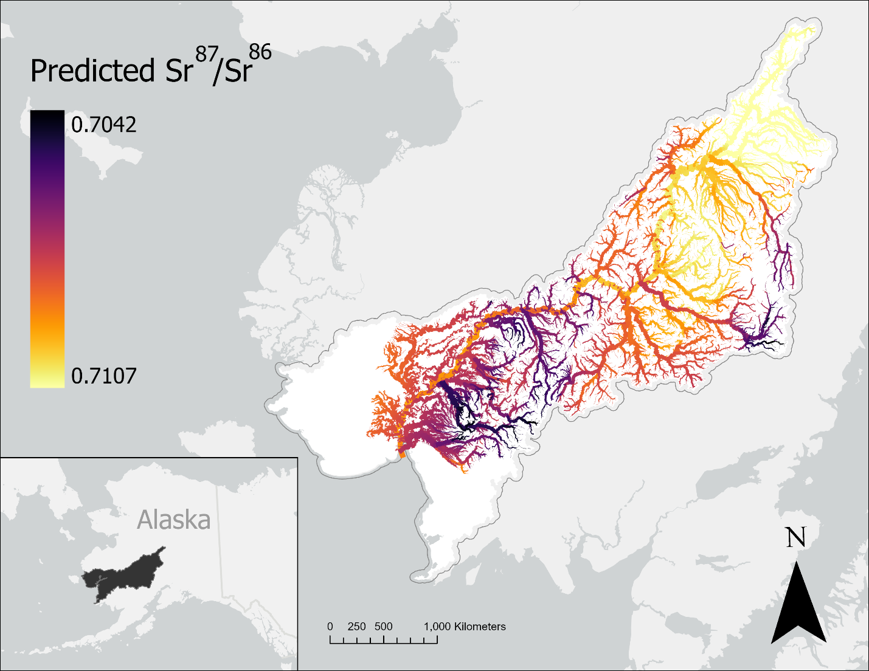
Figure 1: Strontium isoscape of the Kuskokwim River Basin (French et al., 2020) displaying the spatial variation in Sr⁸⁷/Sr⁸⁶ ratios. Darker colors indicate lower relative isotope ratios whereas lighter colors indicate higher values. Isotope ratios across the basin range from 0.7042 to 0.7107, with a general trend towards higher values at the top of the watershed.

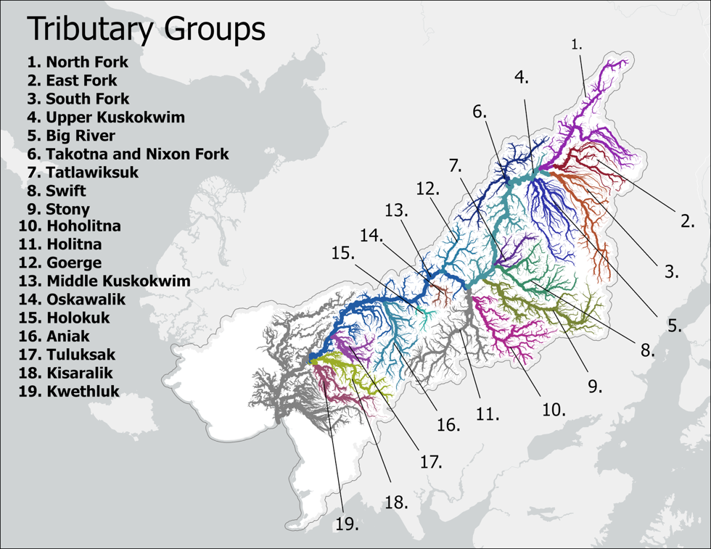

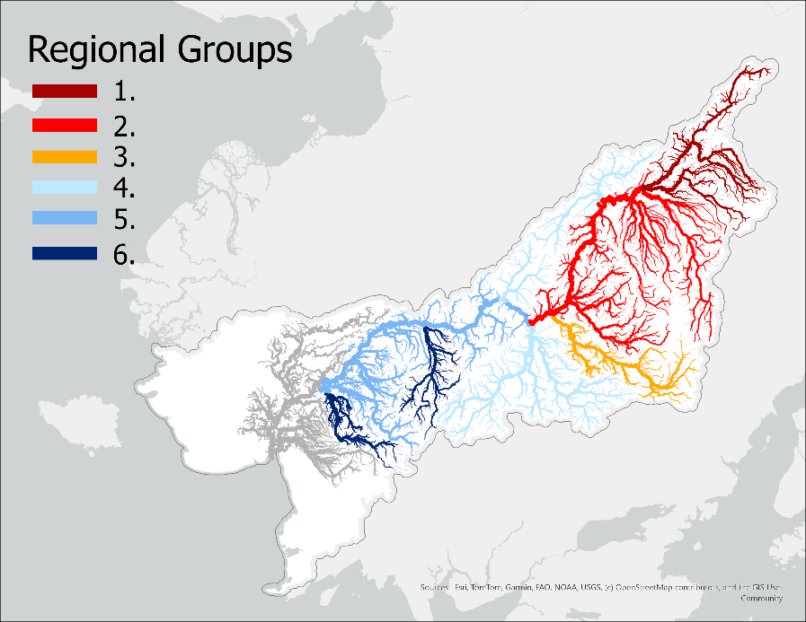

Figure 2:
A) 19 tributary groups selected by collecting the upstream reaches of notable tributaries in the basin. Regions not associated with a tributary (e.g. Lower Kuskokwim) were manually selected to ensure full coverage of the basin.
B) Dix regional groupings based on k-means clustering and evaluation of silhouette score.

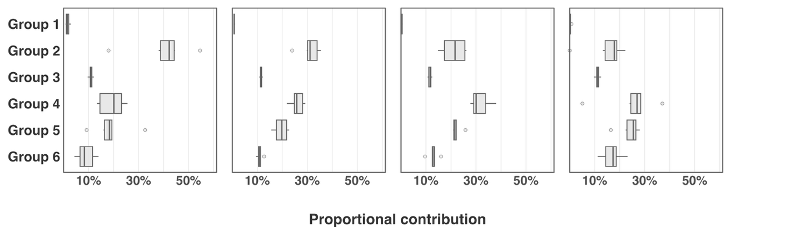

Figure 3: Median proportional contribution of regional groups to each seasonal quartile across all years of the dataset. Boxplots illustrate the range in proportional contribution to each quartile for each stock group across all years of the dataset.

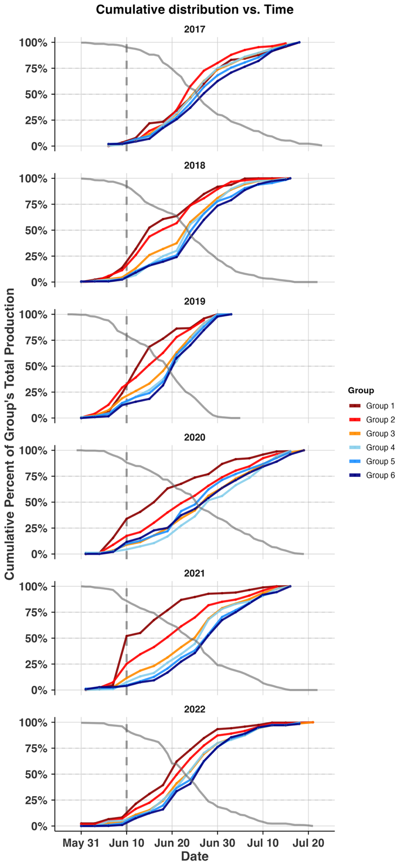
Figure 4: Cumulative distribution plots of returning regional groups to the Bethel Test Fishery in June and July 2017-2022. Lines are colored in order of their watershed position, with the furthest upstream groups in red transitioning towards downstream groups in blue. Grey dashed vertical line illustrates the end of the front-end closure. Grey solid line illustrates the remaining proportion of the total CPUE at each day.

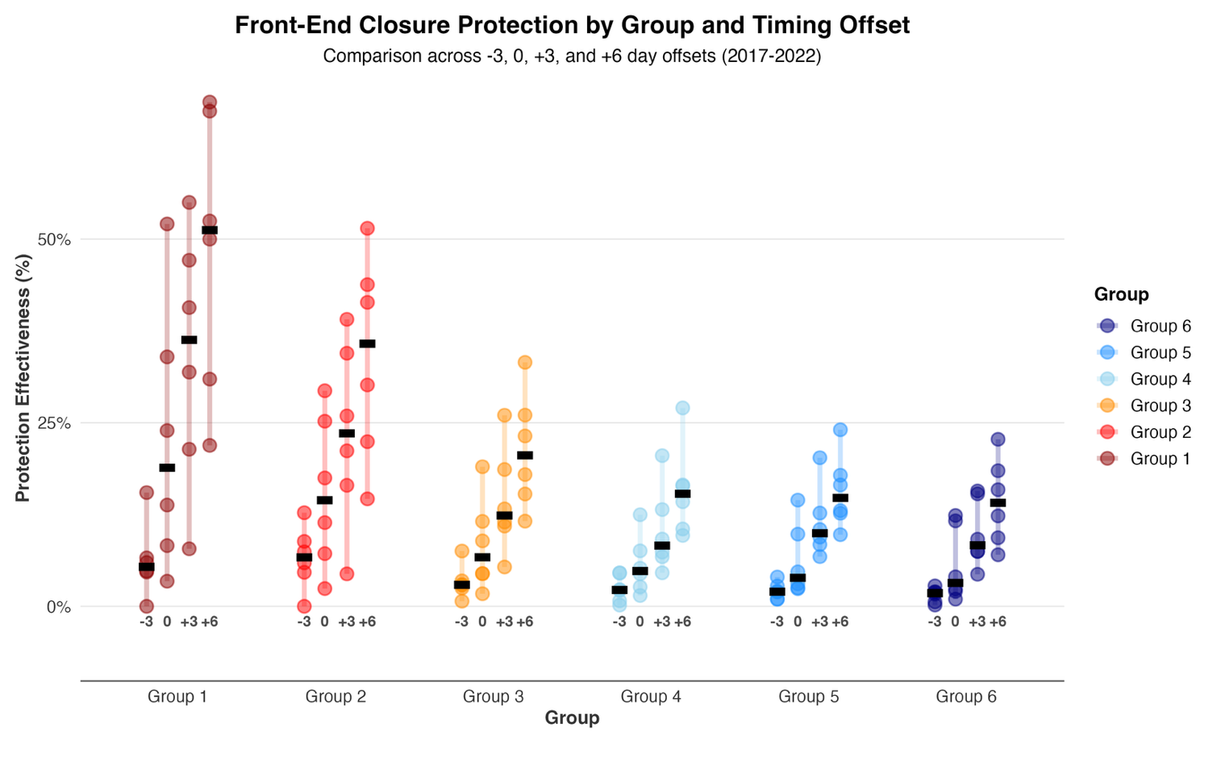
Figure 5: The proportion of each regional group’s total return protected under several simulated front-end closure scenarios, including the current closure. X-axis labels show the number of days the simulated closure end date differs from the current end date (−3 = June 8, 0 = June 11, +3 = June 14, +6 = June 17). Each point represents a single year, colored bars show the year-to-year range, and black lines denote the median across all years. Colors reflect watershed position, with upstream groups shown in red and downstream groups in blue.

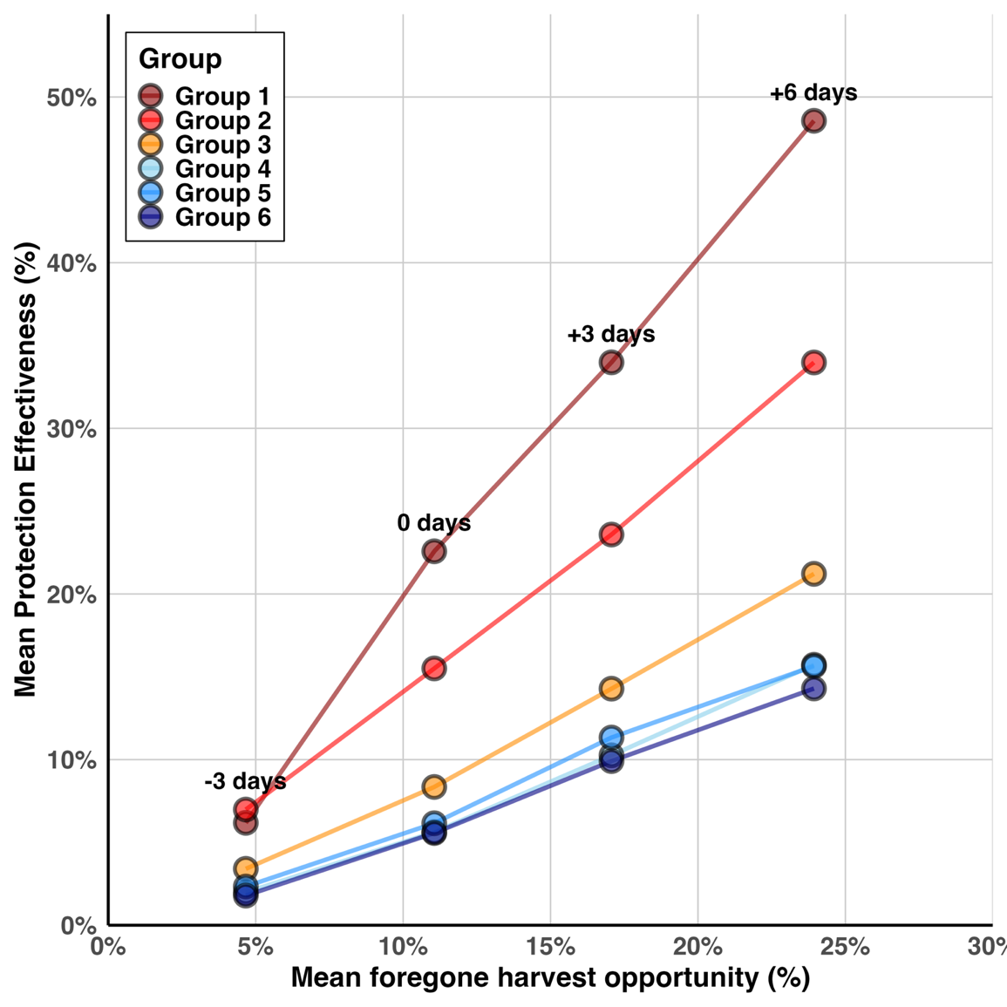
Figure 6: Comparison of the mean protection afforded to each group across all years with the mean foregone potential harvest. Potential foregone harvest is calculated as 1- (cumulative daily CPUE at each closure date/ total summed daily CPUE in that year). Each column of points illustrates a different closure end date scenario.

